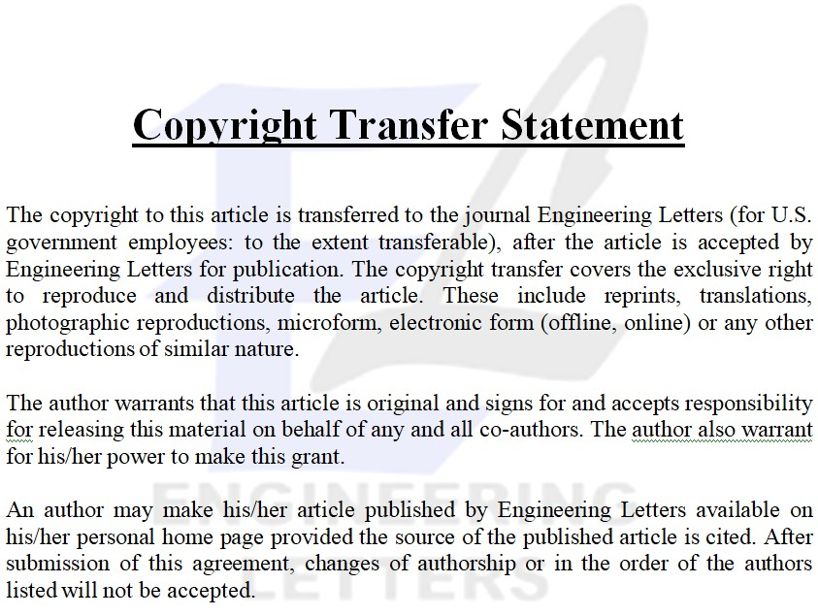

Title of Journal:

Engineering Letters

Title of article:

Author(s):

Author’s signature:

Date:

